Emil M. Winebrand
Co-Founder | CEO
https://www.linkedin.com/in/emil-winebrand/
BIOGRAPHY
Technology innovator, problem solver, dedicated to finding creative solutions and creating cutting-edge technologies.

With over two decades of experience leading technological teams in various fields, including physics, electro-optics, algorithm development, and software engineering, Emil Winebrand has garnered recognition for exceptional technological leadership in prestigious organisations such as The Israel Defense Forces (IDF), Microsoft Surface, and Magic Leap.

Emil Winebrand holds a Master's and Bachelor's degree from the renowned Tel Aviv University's Electrical Engineering Faculty. Emil’s career was kick-started by serving in the IDF's elite intelligence technological unit, where he honed his skills and expertise.

Throughout his journey, he has received numerous accolades and awards for his remarkable innovations. Currently, he holds the position of CEO and are a founding partner of InSoundz LTD, where his visionary leadership continues to shape the future of audio and responsible AI

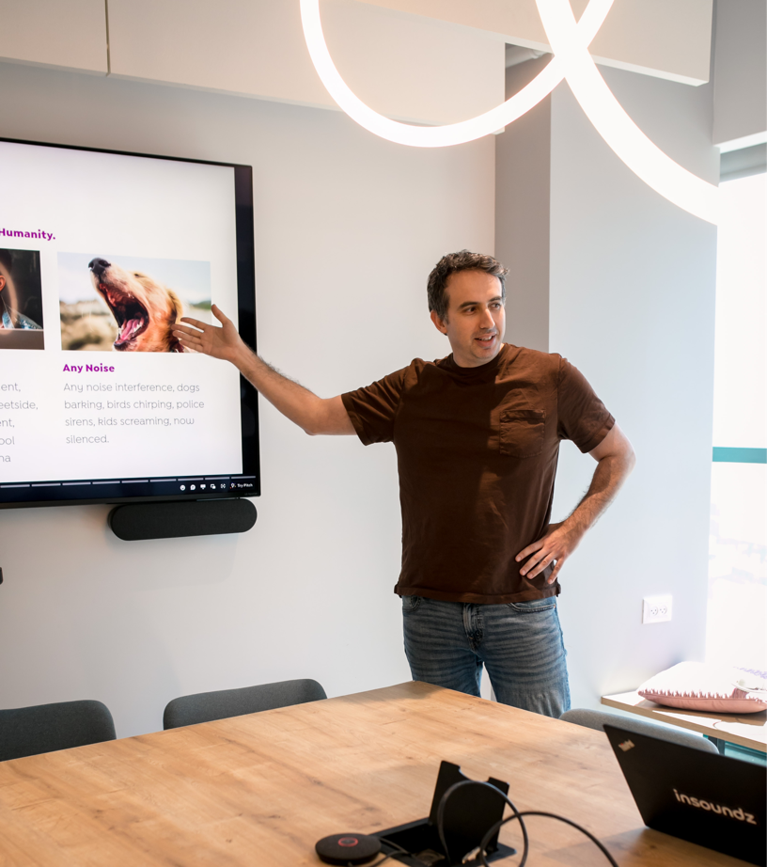
MS.c and BS.c from the Tel Aviv university electrical engineering faculty. Served for 10 years in the IDF’s elite intelligence technological unit. Won multiple awards for innovation. Currently serves as the CEO and a founding partner of InSoundz LTD.

HIGHLIGHTS
- Led start up team to acquisition by Microsoft
- Built and led research groups of 30+ engineers

- Won the prestigious “IDF Intelligence Award for Creative Thinking” and
- played leadership role in teams winning numerous “Israel Defence Awards”

INTERESTS
When not immersed in the world of tech and innovation, Emil is deeply invested in a diverse range of interests. Emil harbours a genuine passion for education, culture, and upholding core family values. His inquisitive mind is further captivated by the fascinating realms of quantum physics, astronomy, and history.

